Multiple Organizations Access Control (MOAC)in Oracle R12

DOCUMENT HISTORY
Version | Date | Comments | Author(s)
01 | 02/11/2017 | Initial version of Multiple Organizations Access Control (MOAC) in Oracle R12 | Sibraj Banerjee

Table of Contents
1. Why MOAC (Mult-Org Access Control)………………………………………………………………………………….3
2. Features ..............................................................................................................................3
3. R12 Multi-Org Architecture .3
4. Setups: Profile Options…………………………………………………………………………………………………………..4
5. Concurrent Programs.............................................................................................................6

Why MOAC (Multi-Org Access Control):
Overview:
Prior to Release 12, each responsibility could access only one operating unit. Therefore, users who had to manage multiple operating units had to log in and log out of multiple responsibilities to perform their tasks. In Release 12, users can perform tasks for multiple operating units without changing responsibilities and its achieved by setting up MO: Security profile.
Usage Example:
In 11i, if a company had three operating units Belgium, Holland, and Denmark, the company would have to create three responsibilities, one for each OU(operating unit). And users, who had to enter invoices into all 3 operating units, had to log into each one of the EMEA responsibilities separately.
With Multi-Org Access Control in R12, each application responsibility can access multiple operating units. The company can create a single EMEA responsibility for all three operating units and users would only have to log in once to perform tasks such as: entering payables invoices, viewing consolidated requisitions, performing collections, and processing receiving and drop shipments.

Features:
- R12 Offers True Multi-Org Access
- Responsibilities are assigned a Security Profile which is a group of Operating Units
- Assignment is through the profile option ‘MO: Security Profile’ set at the Responsibility Level.
- From one responsibility user can perform transactions and report on transactions from multiple operating units
- Desirable in a share services environment
- Users have to be very careful and disciplined while using MOAC
- Even though MOAC is available changing responsibilities to change operating units has some benefits

R12 Multi-Org Architecture:
Pre-R12 Multi-Org Architecture
- Base data tables exist in the product schema with a naming convention of %_ALL. The data in this table is striped by ORG_ID (Operating Unit).
- A view in the APPS schema provides the Multi-Org filtering based on the statement below in the where clause.
SUBSTRB (USERENV ('CLIENT_INFO'), 1, 10)

R12 Multi-Org Architecture
- Base data tables exist in the product schema with a naming convention of %_ALL. The data in this table is striped by ORG_ID (Operating Unit).
- A synonym in the APPS schema provides the Multi-Org filtering based the Virtual Private Database feature of the Oracle 10G DB Server.

Setups: Profile Options

Multiple Organizations provides the following security profiles which enables users to
access, process, and report data in multiple operating units from a single responsibility:
• Security Profile: Allows you to assign multiple operating units for the same
business group.
• Global Security Profile: Allows you to assign multiple operating units across
business groups.

The decision to use the Security Profile or the Global Security Profile depends on your
HR implementation and how you want to partition the data. If you want users to access
operating units across business groups, then define Global Security Profiles. Otherwise,
use the standard Security Profile.
After you define your security profiles and run the Security List Maintenance program,
you can assign them to responsibilities or users using the MO: Security Profile option.
If you set the MO: Security Profile option, you can also set the MO:
Default Operating Unit profile option to specify a default operating unit.
Note: If the MO: Security Profile is set, then the MO: Operating Unit
profile is ignored.

You must set either the MO: Operating Unit or MO: Security Profile profile option for
each application responsibility to use Multiple Organizations context sensitive
applications.
When drilling down on balances from Oracle General Ledger, General Ledger ignores
the operating unit profile setting to allow you to drill down to your subledger details,
regardless of which operating unit originated the transaction.

Multiple Organizations Profile Options
When implementing multiple organizations for Oracle Applications, you must set
values for each profile option to specify how each product in Oracle Applications
controls access to and processes data.

The following are the Oracle Applications multiple organizations profile options and
are grouped under the Access Control profile option category:

- MO: Default Operating Unit
Use this profile option to specify a default operating unit from the list of operating units
assigned to your application responsibility through the MO: Operating Unit or MO:
Security Profile.
Note: If the MO: Operating Unit is set or you are assigned only one
operating unit in the MO: Security Profile option, then the single
operating unit becomes your default operating unit.

- MO: Operating Unit
Assign this profile option to an application responsibility to provide a user with this
responsibility access to one operating unit.

- MO: Security Profile
Assign this profile option to an application responsibility to provide a user with this
responsibility access to multiple operating units.

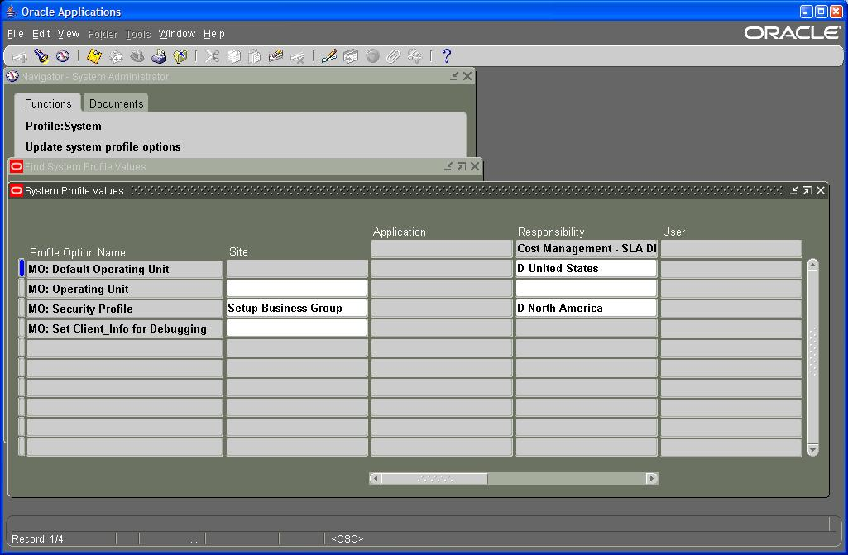

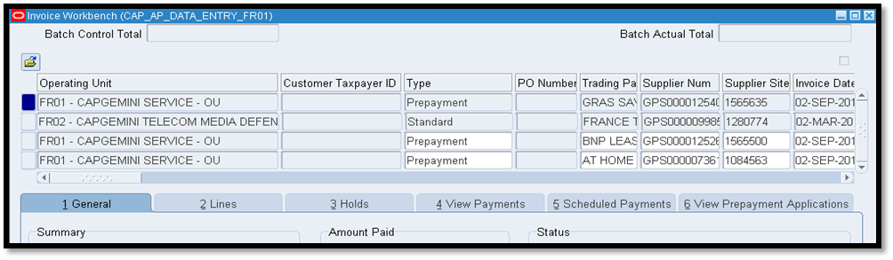

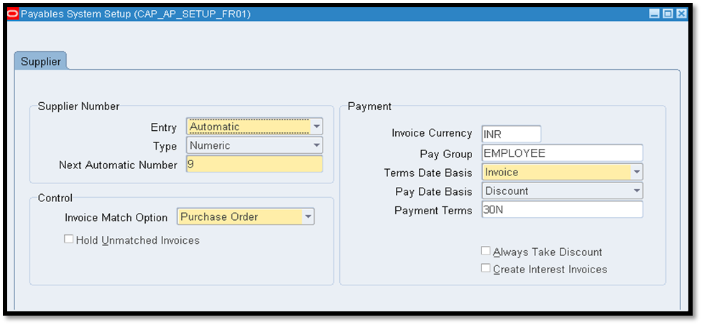

Several controls are moved from the Payables Options or Financials Options forms to a new setup form that is common for Oracle Payables across all operating units, the Payables System Setup form
Concurrent Programs
Oracle has implemented a new parameter on the System Administration: Concurrent Parameters form to control how to handle Operating Units.
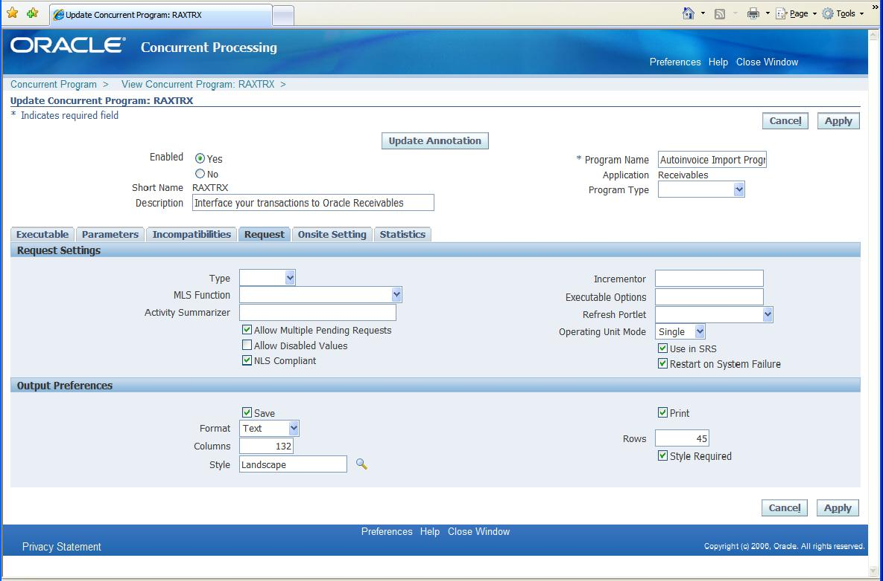

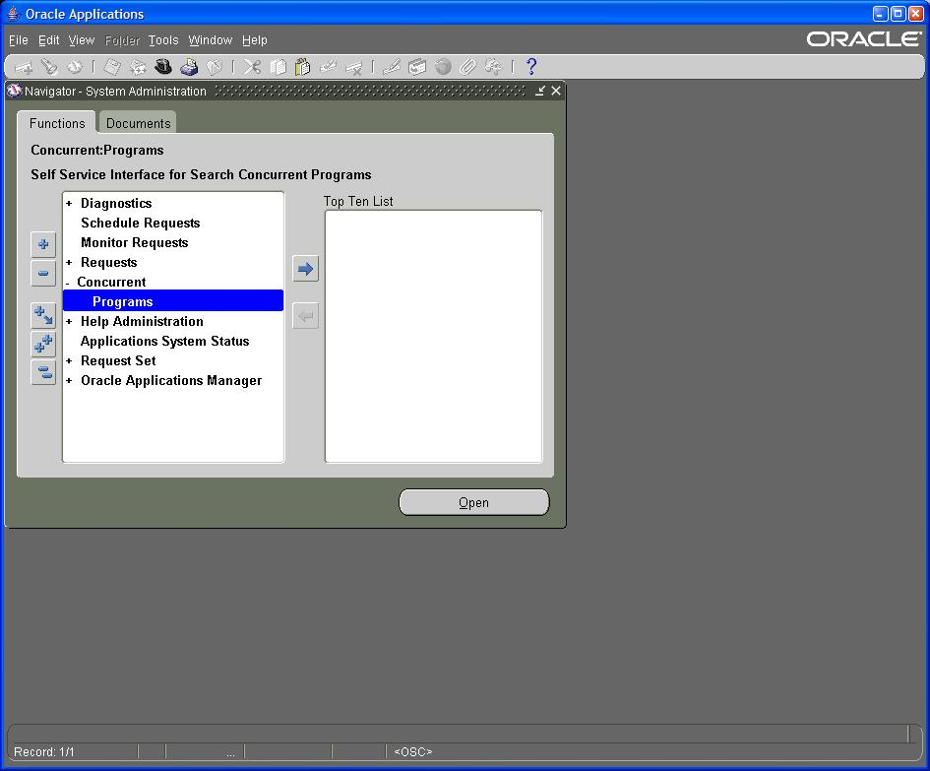

The Operating Unit Mode parameter does not show up in the System Administrator: Define Concurrent Programs form.

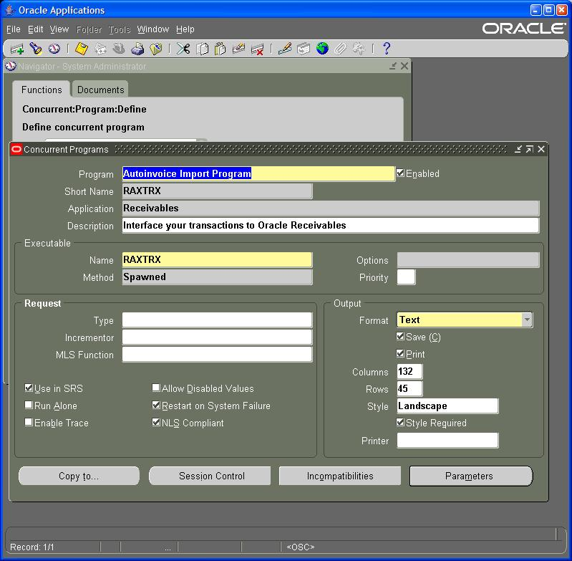

Parameters:

The Operating Unit Mode parameter is not always set properly by Oracle Development during an upgrade.

This setting has three values:
NULL – default setting

Single – run only for a specific Operating Unit specified by ‘MO: Operating Unit’ profile option

Multi – run for multiple Operating Units based on the ‘MO: Security Profile’ profile option

Change this setting from the default NULL setting to Single to see if this resolves report execution errors.

This Operating Unit Mode parameter is used to identify:

How the program executes the multiple organizations initialization

When to display Operating Unit prompt in the Submit Requests window and Schedule Requests window.

This impacts how the Submit Requests form evaluates Concurrent Request Parameter List of Values. If you don’t see what you want try changing this setting.

